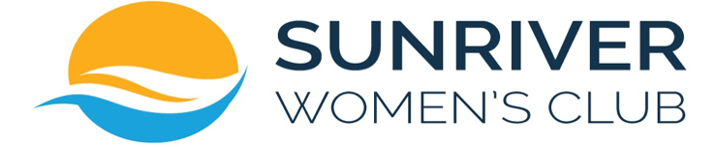

Board Meeting Agenda, July 14, 2022

Call to Order
Roll Call
Proxy: Tina Freel for Val Stensland

Minutes
Motion to Approve the Minutes from the Board meeting June 13, 2022

Old Business

New Business
- Board Reports - Baker
- Treasurer’s report & 2022/23 Budget format – Parrish
- Motion to approve Linda Gocke for the Philanthropy Committee – Ketchum
- Dues increase discussion – Baker
- Email, Name & Signature line– Besson
- Art Fair Director & Assistant Director – Meyer
- Crosswater Luncheon Price – Bourret
- Winter Social - Bourret
- We Care – LeCuyer
- Member overload/burnout - Baker
- Happy Hour – Baker
- Wild Apricot – Besson
- Welcome Back - Baker

Announcements
- Locks have been changed at Storage Unit
- Happy Hours scheduled Friday July 15th & August 1st at 4:00 pm, Mary McCallum Park. Please come and welcome new friends!
- Community Picnic July 20th at 4:00 pm – dusk, Mary McCallum Park. Please come and welcome new friends!
- Art Fair August 12, 13 & 14
- Welcome Back September 6th at Mary McCullum Park, 4:00 pm
Adjourn

